Board Charter
March 2023

Contents
Introduction 2
Company Purpose 2
Governance Processes 3
The Board’s Relationship With Its Shareholder 3
Board Procedures 3
Chairperson and Deputy Chairperson 4
Board Remuneration 5
Provision of Professional Services by Board Members 5
Other Board Appointments 5
Professional Development 5
Board Evaluation 5
Health and Safety 5
Indemnities And Insurance 5
Company Secretary 6
Board/Management Relationship 6
Governance Map 7
Version Control 8

Introduction
This Charter outlines the expectations of the Board and its relationship with the Chief Executive (CE).
It will be reviewed annually.
A Governance Roadmap detailing Board responsibilities and relationships is appended to this Charter.

Company Purpose
The purpose of Rau Paenga Limited (Company) is to:
- Act as a partner and advisor to the Government and Project Owners to lead and/or support the delivery of horizontal and vertical infrastructure projects and programmes;
- Provide project support and delivery services (including procurement and preparation and review of business cases) to Project Owners for horizontal and vertical infrastructure projects and programmes, as agreed between the Company and the Shareholding Ministers and/or the Company and Project Owners, from time to time;
- Add value to the delivery of Anchor Projects, and divest and manage the Anchor Project Assets where required by, and/or agreed by the Company, with Shareholding Ministers;
- To:
  - divest; or
  - where required by, and/or agreed by the Company with Shareholding Ministers, manage,
Crown-owned Assets (including Crown-owned Land, but not including Anchor Projects) in a manner that balances a desire to achieve good commercial outcomes against the Crown’s regeneration objectives; and
- Undertake any role, and take any action to assist the government with any projects and programmes, as agreed between the Company and the Shareholding Ministers from time to time.

Governance Processes
The role of the Board is to effectively represent and promote the interests of the Company with the intent of achieving the Company’s purpose.
The Board will direct and supervise the management of the Company’s affairs by:
- Chartering the Company’s direction and strategies (including setting clearly defined goals);
- Appointing and removing the CE and setting the terms and conditions of his/her employment;
- Leading the values and behaviours expected of the Company to deliver on its purpose and strategic objectives;
- Monitoring the Company’s financial performance and taking whatever steps are necessary to protect its financial position;
- Setting the Company’s risk appetite statement and overseeing its risk management framework and strategies; and
- Overseeing the Company’s compliance with all legal, regulatory, ethical and other external requirements including workplace health and safety and employee wellbeing.

The Board’s Relationship with its Shareholder
The Company is 100% owned by the Crown and ownership rights are exercised through two Shareholding Ministers, the Minister of Finance and the Minister for Infrastructure.
The Board will familiarise itself with issues of concern to the Shareholder and ensure Ministers are kept well informed on a ‘no surprises’ basis.

Board Procedures
The Board will carry out its role with an emphasis on strategic issues and policy.
Board discussions will be open and constructive.
Wherever possible the Board will operate transparently and ‘Board only’ sessions will be restricted to items that are commercially sensitive and/or required to be confidential to the Board.
Decisions will be by consensus wherever possible. The Chairperson may, if necessary, call for a vote.
The Board will meet monthly (except January) or more often if required. In ordinary circumstances, up to two meetings a year may be held via video. The Chairperson shall determine the extent that Board members are expected to attend other meetings in person. Alternate Board members are not accepted.
At each meeting the Board will consider:
- An update of members’ interests.
- The CE’s Report including an update on health and safety, employee wellbeing and all areas of operational activity including financial reports.
- All areas of high risk to the Company.
- Specific proposals for capex or non-budgeted expenditure.
- Major strategic issues and opportunities for the Company.

At intervals of not more than one year the Board will:
- Review the Company’s goals.
- Review strategies and operating plans for achieving the goals.
- Approve the Statement of Intent, Statement of Performance Expectations, and the Business Plan.
- Approve the annual budget.
- Approve annual Financial Statements and reports to the Shareholder.
- Approve the Annual Report.
- Approve the audit requirements.
- Undertake a Board evaluation.
- Review the CE’s performance and remuneration.
- Review risk assessment policies, compliance, and insurance.

Chairperson and Deputy Chairperson
The Responsible Minister will appoint the Chairperson and may appoint a Deputy Chairperson.

Board Composition
- The composition of the Board will be such as to enable it to effectively discharge its duties to the Shareholder.
- Each member will act in accordance with their fiduciary responsibilities.
- Members will declare, avoid or manage any conflicts of interest.
- Treasury manages the process to appoint directors on behalf of the Ministers.
- On appointment members will participate in an induction programme.
- The Board shall appoint an Audit and Risk Subcommittee that will meet quarterly.

Board Remuneration
Directors’ fees are set by the Ministers, subject to Cabinet approval.

Provision of Professional Services by Board Members
Board members should not provide external business or professional services to the Company without the specific authority of the Chairperson in writing.

Other Board Appointments
Board members may have other roles where they do not create a conflict of interest.

Professional Development
Board members are expected to undergo regular professional development, which will be reimbursed by the Company within prescribed limits.

Board Evaluation
The Board will undertake annual individual and collective assessments of its performance.

Health and Safety
Board members are committed to providing leadership and direction for the health and safety management of the Company, by exercising “due diligence” as required by the Health and Safety at Work Act 2015 and as set out in the Board’s Health and Safety Charter. In this way, the Board will also provide leadership across the construction sector.

Indemnities And Insurance
The Company will provide members with paid indemnity and insurance cover, in accordance with its Constitution.

Company Secretary
A Company Secretary will be appointed by the Board on the recommendation of the CE. The Company Secretary will ensure the Company’s procedures and legal requirements are complied with.

Board/Management Relationship
- The Board will link the Company’s governance and management functions through the CE.
- All Board authority conferred on Management is delegated through the CE.
- The CE is responsible for all employees.
- Between Board meetings the Chairperson will maintain a regular, informal link between the Board and the CE.
- The CE, in association with the Chairperson, is accountable for the achievement of the Company’s goals.
- The CE will act within all specific authorities as delegated by the Board, including the efficient management of risk, the welfare of all staff and the protection of the Company’s resources.
- The CE will ensure that all employees are working in a flexible, empowering and supportive environment.

Governance Map
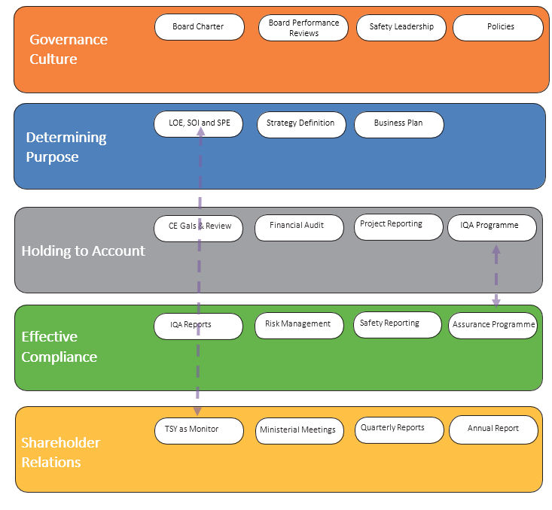

Version Control
Version | Date | Author | Description
2 | January 2023 | Sam Jack | Recommended amendments
2.1 | February 2023 | Sam Jack | Board approval subject to confirmation of constitution, name change etc.
2.2 | August 2023 | Rachal Aspinall | Updated for Rau Paenga branding

